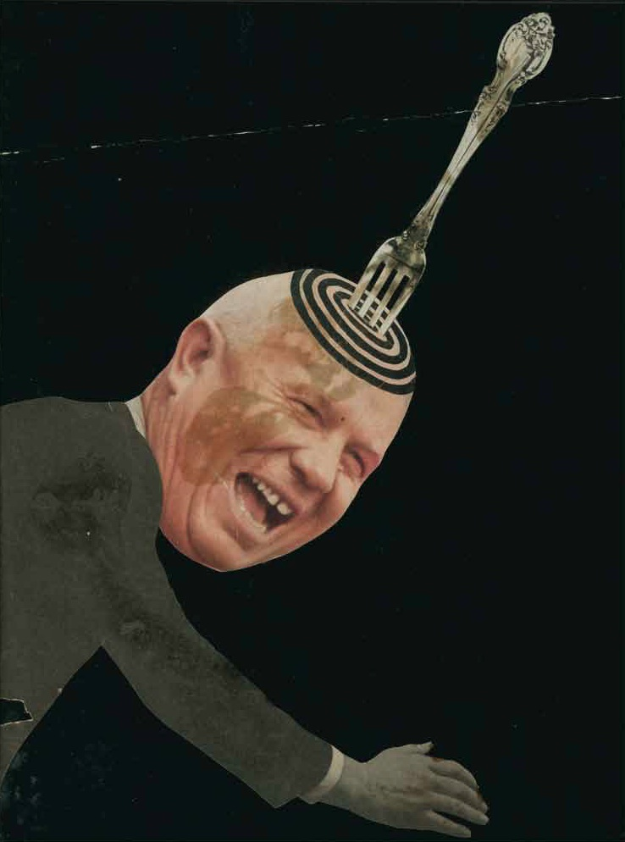

Stan VanDerBeek, collage element, *Science Friction* (1959, color, sound film) (permission Artist’s estate)

VanDerBeek, Stan (1927-1984)

Erika Levin (University of California, Berkeley)

Stan VanDerBeek is an American artist (b. New York City, United States) widely regarded as a pioneer and visionary in the field of experimental media. VanDerBeek coined a number of indispensible terms that describe the myriad paths he pursued as an innovator of new media forms, including “underground cinema,” “expanded cinema,” and possibly “social media,” using the phrase as early as 1974. His first cut-out animations and collage films were produced in the late 1950s after picking up a Bolex camera at Black Mountain College. As more advanced technologies became available, he embraced the possibilities opened up by video processing and early computer graphics. VanDerBeek not only focused on new modes of image production, he also imagined alternatives to conventional forms of viewing and distributing moving images, devising a proposal for a system of satellite-linked “movie-dromes” (dome-shaped theaters built for multi-channel immersive screenings), media labs, and image archives that he called a “Culture Intercom.” VanDerBeek envisioned a future in which increased access to the tools of multimedia production would enable networked exchange across the globe. His prolific output and creative re-appropriation of the flotsam and jetsam of mass culture anticipated the antic eclecticism of a user-generated social media culture yet to come.

[***Works (available on video)***](http://www.eai.org/artistTitles.htm?id=324)

**Science Friction** *1959, 9:46 min, color, sound*

**A La Mode** *1959, 6:18 min, b&w, sound*

**Breathdeath** *1963, 14:33 min, b&w, sound*

**Poemfield No. 2** *1966, 5:40 min, color, sound*

**Achooo Mr. Kerrooschev** *1960, 1:43 min, b&w, sound*

**See Saw Seams** *1965, 9:06 min, b&w, sound*

**Panels for the Walls of the World** *1967, 7:57 min, b&w, sound*

**Oh** *1968, 9:17 min, color, sound*

**Symmetricks** *1972, 6:12 min, b&w, sound*

**Newsreel of Dreams: Part I** *1976, 28 min, color, sound*

**Strobe Ode***1977, 11 min, color, sound*

**Vanishing Point Left** *1977, 9:30 min, color, sound*

**Color Fields Left** *1977, 7:47 min, color, sound*

**Mirrored Reason** *1979, 9:22 min, color, sound*

**Face Concert** *1981, 11:54 min, color, sound*

**After Laughter** *1981, 7:28 min, color, sound*

**Reeling in TV Time** *1983, 3:40 min, color, sound*

**Self-Poured Traits** *1983, 4:52 min, color, sound*

**Sonia and Stan Paint a Portrait of Ronnie** *1983, 13:30 min, color, sound*

**Drawn Conclusions (Parts 1 and 2)** *1983, 56:40 min, color, sound*

**Micro Cosmos 1-4** *1983, 15 min, color, sound*

***Further Reading***

*Stan VanDerBeek: The Culture Intercom* (2011) Texts by Bill Arning, Joao Ribas, Jane Farver, Jacob Proctor, Gloria Sutton, Michael Zyrd, Stan VanDerBeek. New York: Distributed Art Publishers.

Sutton, G. (2003), “Stan VanDerBeek’s Movie-Drome: Networking the Subject” in Future Cinema: The Cinematic Imaginary After Film, eds. Jeffrey Show and Peter Weibel. Cambridge: MIT Press: 136-43.

Uroskie, A. (2010) “From Pictorial Collage to Intermedia Assemblage: Variations V (1965) and the Cagean origins of VanDerBeek's Expanded Cinema.” *Animation: an interdisciplinary journal* 5 (2): 223-41.

VanDerBeek, S. (1966) “‘Culture: Intercom’ and Expanded Cinema: A Proposal and Manifesto.” *The Tulane Drama Review* 11 (1): 38-48.